The week in 7 charts
28th of September 2026

------------------------------------------------------------------------------------------------------------------------------

Chart #1: The 10-year Treasury yield just surged above 5.20% for the first time in 19 years.

The US 10-year Treasury yield has climbed nearly 30 basis points in only two days, one of the sharpest bond selloffs in years. Yields were last at comparable levels in 2007, the year the US economy slipped into the recession that ultimately turned into the Global Financial Crisis.

There are clear drivers behind the move. September’s flash PMI reached a five-year high, inflationary pressures are building again and markets are pricing in a more hawkish Fed. Meanwhile, oil is hovering close to $100 and heavy government borrowing continues to weigh on the bond market.

That is why the 5.20% level matters. The 10-year Treasury serves as the benchmark for mortgage rates, corporate borrowing costs and valuations across financial markets, so each further rise adds pressure to the financial system as a whole.

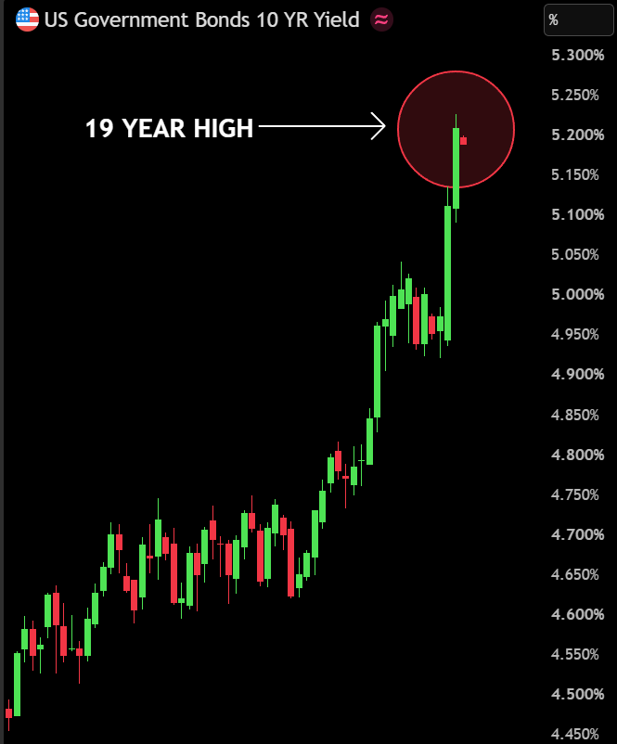

Source: Bull Theory

Chart #2: The gap between US earnings growth and the rest of the world has never been wider:

Since 1990, US corporate earnings have increased by almost +1,300%, compared with a +500% rise for companies outside the US over the same period. US earnings growth has therefore been 2.6 times that of the rest of the world. Over the same span, profit growth outside the US was broadly flat between 2008 and 2025. The US economy stands apart.

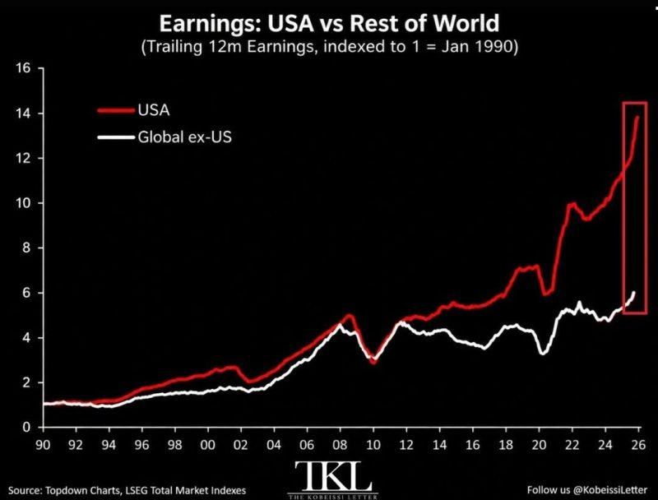

Source: The Kobeissi Letter

Chart #3: America’s debt problem is becoming a growth test

Gross federal debt stood at roughly 63% of GDP when Bill Clinton entered office. The most recent figure exceeds 122%.

Wars, tax cuts, financial crises, a pandemic and mounting long-term spending have all contributed. Interest costs are now adding to the total, with the CBO projecting net interest outlays of more than $1 trillion in 2026.

How, then, can the US regain control?
→ Faster growth: raise productivity and lower the barriers to investment.
→ Long-term costs: put Social Security and Medicare on a sustainable footing.
→ Funding new commitments: pay for spending increases and tax cuts rather than borrowing to finance them.

Growth is the most attractive way out, and AI may help provide it.

The question is whether AI-driven productivity gains can outpace the debt and its interest costs, or whether the temptation to inflate the burden away will keep growing.

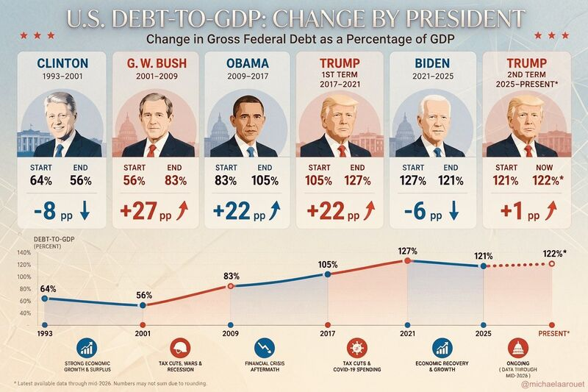

Source: Michel A.Arouet

Chart #4: China has spent a record amount on gold imports this year

China imported over 1,000 tonnes of gold in the first eight months of 2026, at a record cost of $158.8 billion, already well above the $96.5 billion spent over the whole of 2025. The demand is not limited to the central bank. With a weak property market, subdued equities and low bond yields, Chinese households and investors are turning to gold as a store of wealth that does not depend on any issuer’s promise to pay. At the same time, China’s holdings of US Treasuries dropped to $618 billion in July, the lowest since 2008.

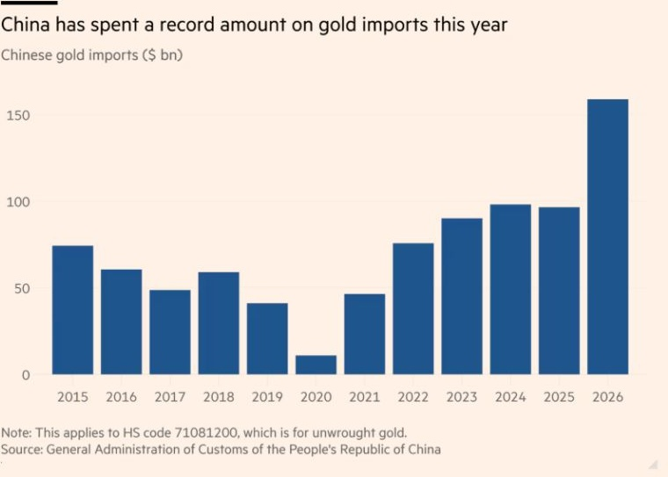

Source: FT

Chart #5: Apple raised the iPhone price 6.3% this year, yet in gold the phone in your pocket still got cheaper

Priced in gold, the 1 TB iPhone 18 Pro Max costs 0.38 ounces, less than half the 0.92 ounces of the first model in 2007. This year also marks the 20th edition of both the iPhone and the In Gold We Trust Report.

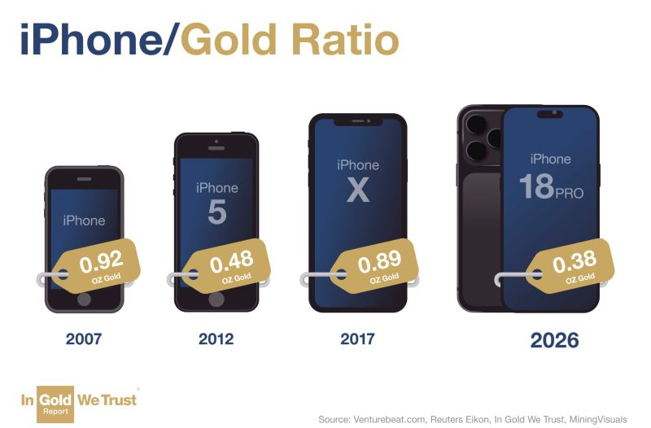

Source: In Gold we trust

Chart #6: The price of artificial thought may have fallen faster than for any transformative technology in history

AI costs are declining faster than those of any previous transformative technology. For a given level of performance, prices have dropped by around 47% per quarter since 2023.

This pace is 4× that of DNA sequencing, 6× that of compute, 18× that of lithium batteries and, through 1973, 54× that of electricity.

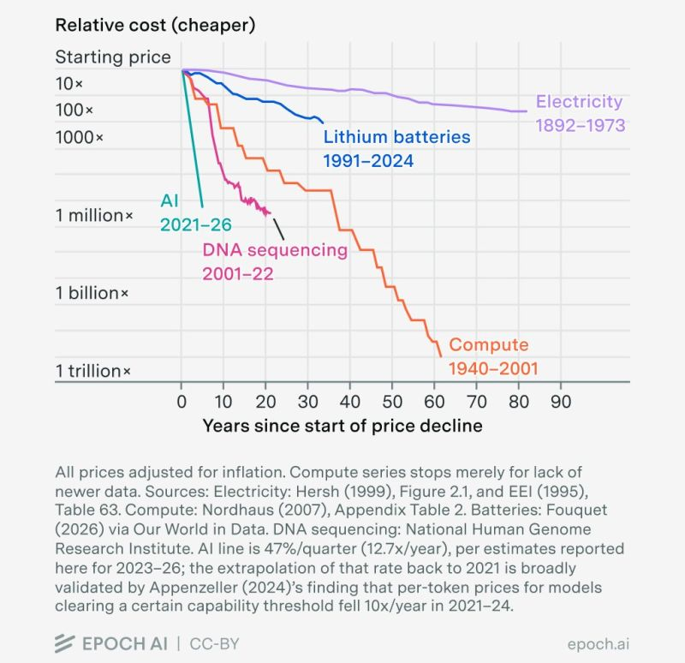

Source: Epoch AI

Chart #7: Trump’s net worth hit $7 billion in 2026.

According to Forbes data, this is three times its level in early 2024.

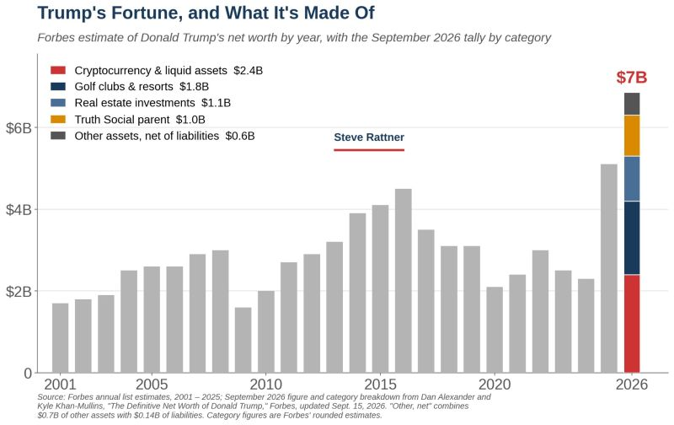

Source: Steve Rattner

